Table of Contents
Pico Wiring for: 2
Lesson 1 – LabVIEW “Hello World” LED On/Off 2
Lesson 2 – For Loops 2
Lesson 3 – While Loops 2
Lesson 4 – Event Structure 2
Pico Wiring for: 3
Lesson 5 – Numbers, Graphs and Charts 3
Exercise – Use DI to stop the loop 4
Analog Output (Write) 5

Pico Wiring for:

Lesson 1 – LabVIEW “Hello World” LED On/Off

Lesson 2 – For Loops

Lesson 3 – While Loops

Lesson 4 – Event Structure
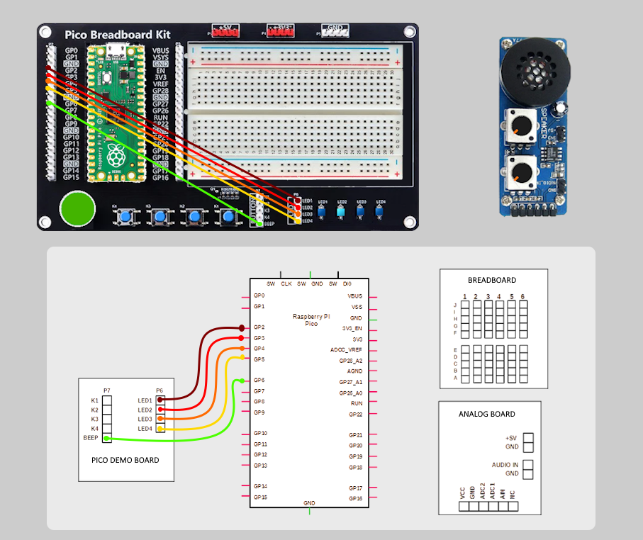
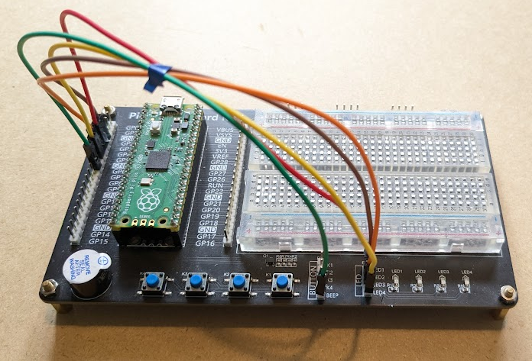

Pico Wiring for:

Lesson 5 – Numbers, Graphs and Charts
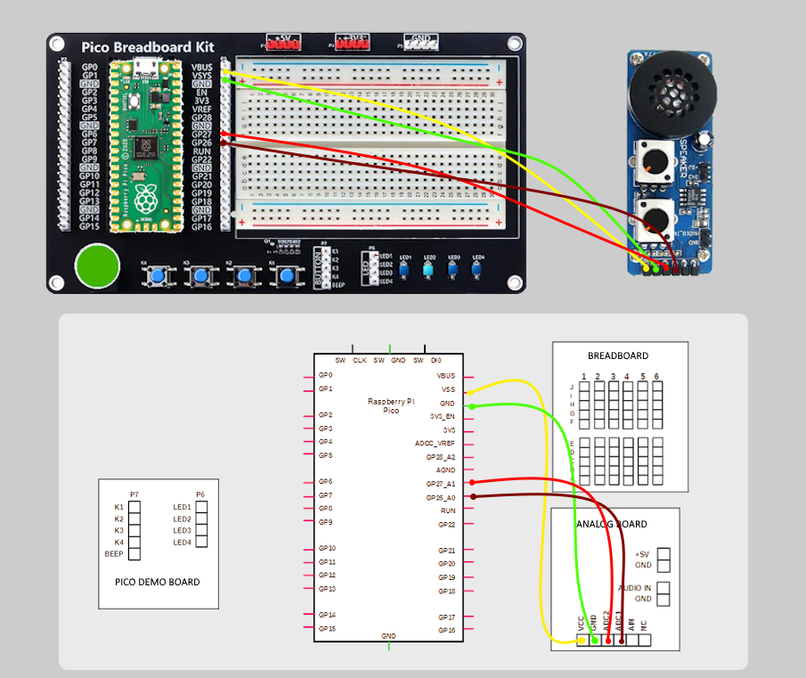
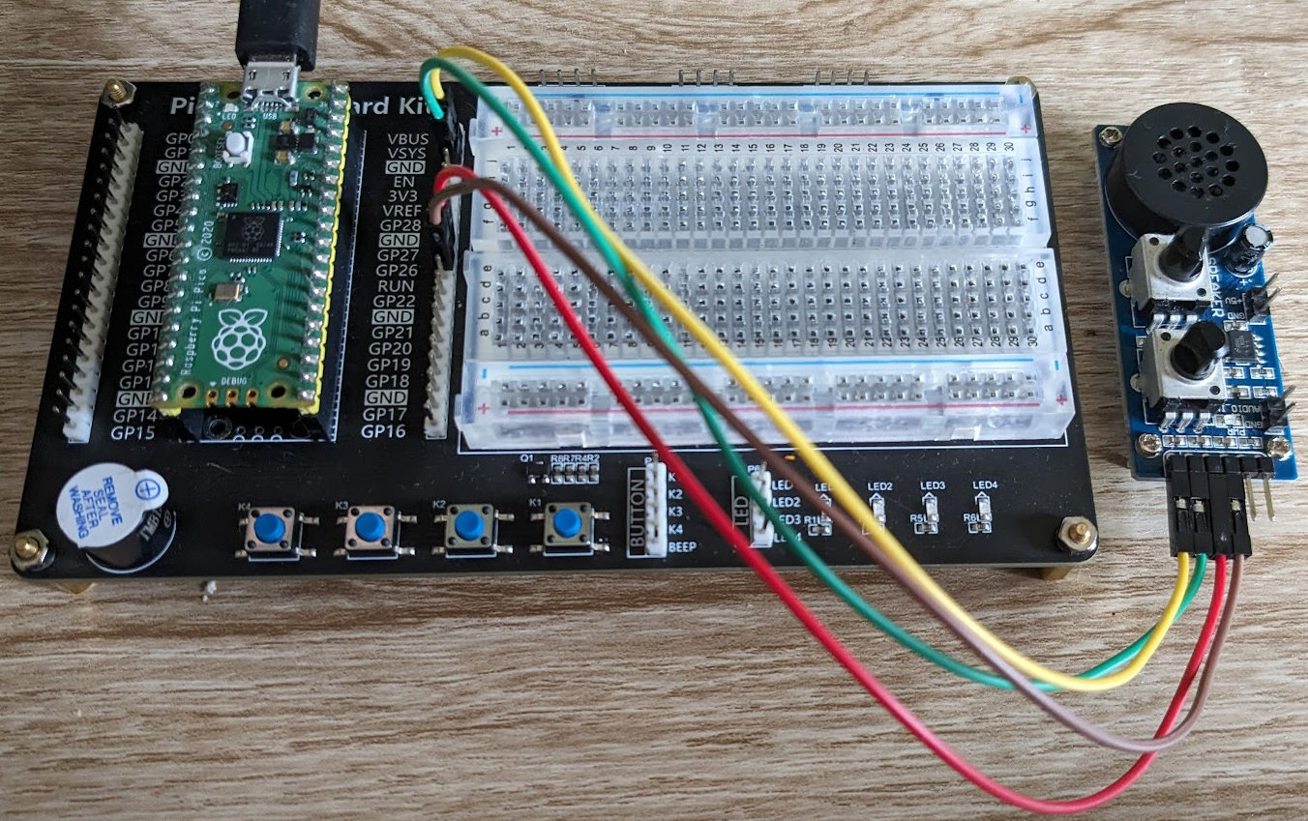
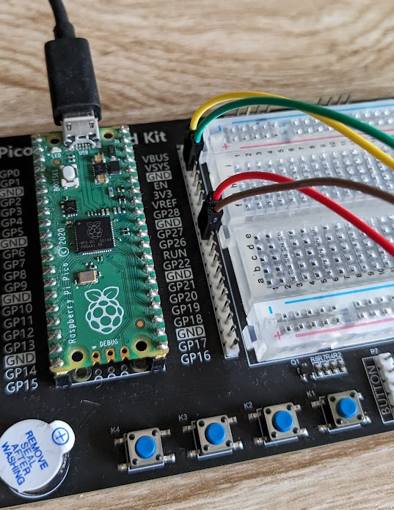

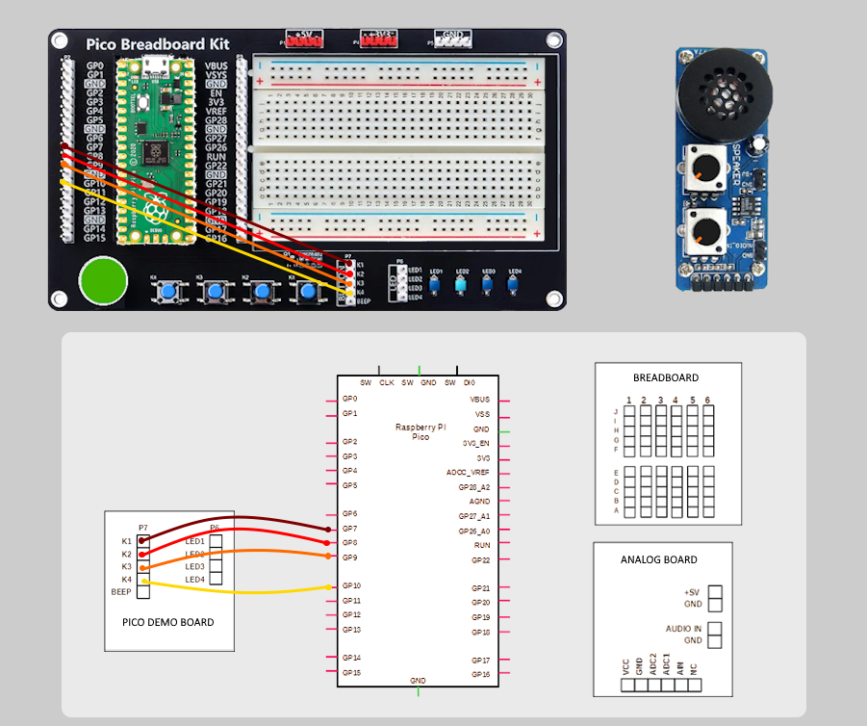
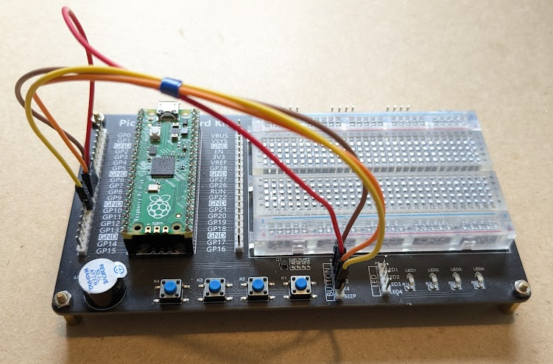
Exercise – Use DI to stop the loop

Analog Output (Write)


